Create database 21201207_CSE370_Lab2

create table employees

-> (employee_id char(10),

-> first_name varchar(20),

-> last_name varchar(20),

-> email varchar(60),

-> phone_number char(14),

-> hire_date date,

-> job_id char(10),

-> salary int,

-> commission_pct decimal(5,3),

-> manager_id char(10),

-> department_id char(10));

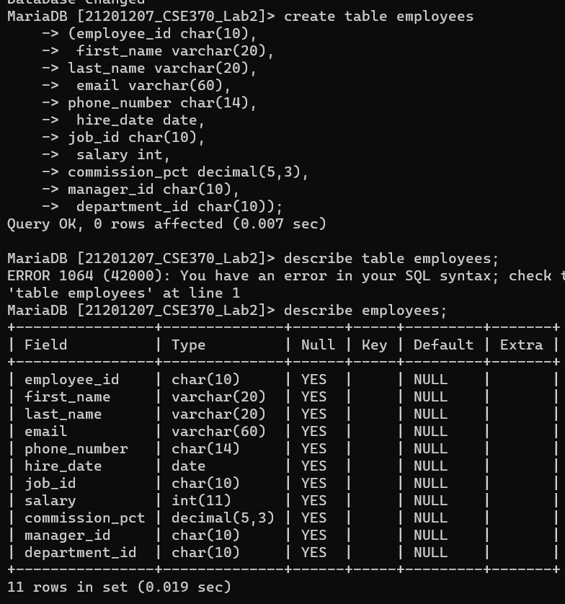

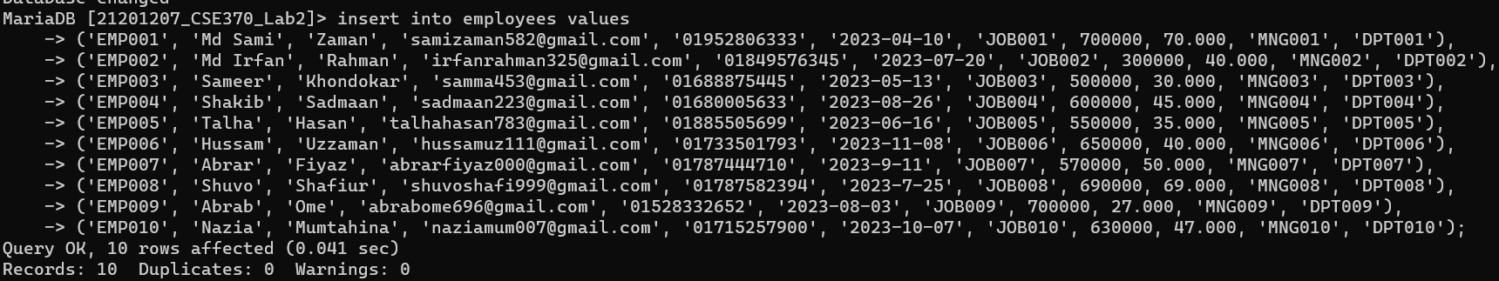

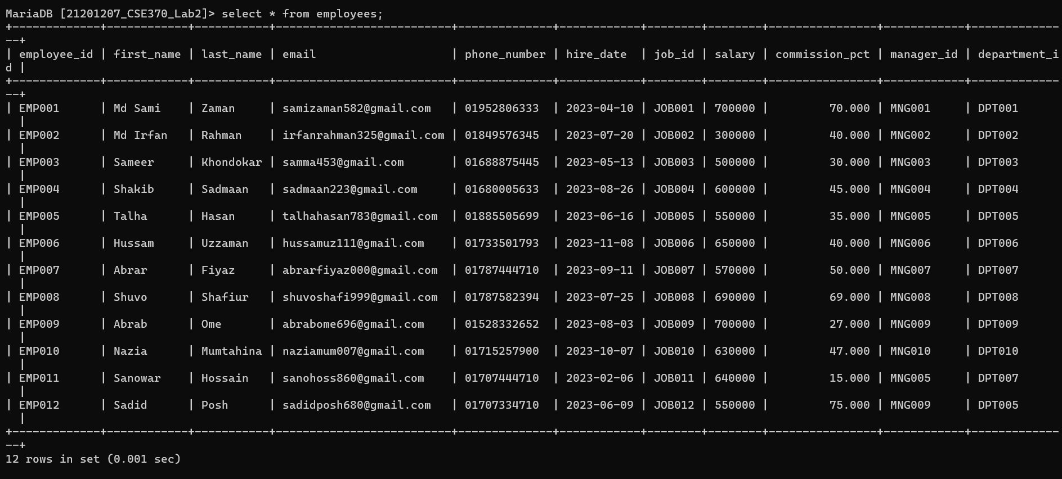

1. Find the **first_name, last_name, email, phone_number, hire_date** and **department_id** of all the employees with the latest **hire_date**

**select first_name, last_name, email, phone_number, hire_date and department_id from employees where hire_date = (select max(hire_date) from employees);**

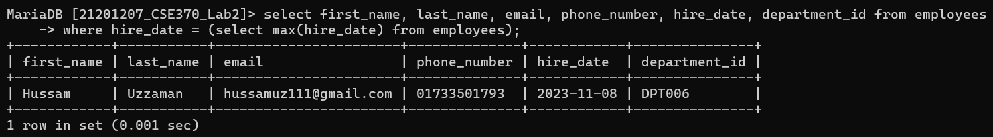

1. Find the ***first_name*, *last_name*, *employee_id*, *phone_number, salary*** and ***department_id***of all the employees with the lowest **salary** in each department.

select first_name, last_name, employee_id, phone_number,salary and department_id from employees where salary = (select min(salary) from employees) group by department_id;

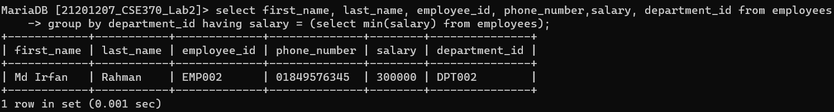

1. Find the ***first_name****,* ***last_name****,* ***employee_id****,* ***commission_pct*** *and* ***department_id*** of all the employees in the department 'DPT007' who have a lower commission_pct than all of the employees of the department 'DPT005'.

select first_name, last_name, employee_id, commission_pct, department_id from employees where commission_pct < all(select commission_pct from employees where department_id = 'DPT005') and department_id = 'DPT007';

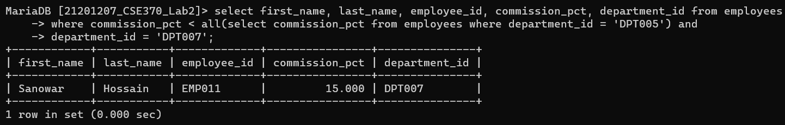

1. Find the **department_id** and total number of employees of each department which does not have a single employee under it with a **salary** more than 30,000.

select distinct department_id, count(*) as total_employee from employees e1 where not exists(select * from employees e2 where e2.salary > 30000 and e2.department_id = e1.department_id);

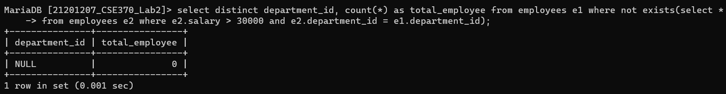

1. For each of the departments, find the ***department_id***, ***job_id***and ***commission_pct***with ***commission_pct***less than at least one other ***job_id***in that department.

select department_id, job_id, commission_pct from employees e1 where exists (select * from employees e2 where e2.department_id = e1.department_id and e2.job_id != e1.job_id and e2.commission_pct < e1.commission_pct);

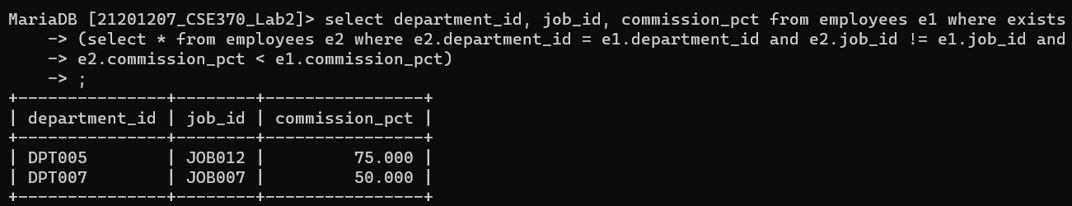

1. Find the ***manager_id*** who does not have any employee under them with a ***salary*** less than 3500.

select distinct manager_id from employees e1 where not exists(select * from employees e2 where e2.manager_id = e1.manager_id and e2.salary < 3500);

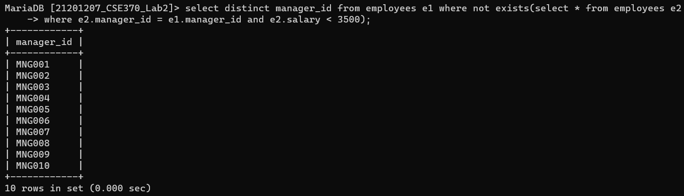

1. Find the ***first_name*, *last_name*, *employee_id*, *email, salary,******department_id*** *and* ***commission_pct***of the employee who has the lowest ***commission_pct***under each manager.

select first_name, last_name, employee_id, email, salary, department_id, commission_pct from employees where commission_pct in (select min(commission_pct) from employees group by manager_id);

